**Installing OPENCV 3.0 with python 2.7**

In this tutorial we will tell how to install opencv.3.0.0 along with python. Till the end of this tutorial you will be ready to start working on Python on your Raspberry Pi. This installation requires time of 3-4, hence one need to be patience. There are different versions of OpenCV for example 3.0.0, 2.4.10, 2.4.5 etc. Here we are going to use latest version which is OpenCV 3.0.0. Before this one must make sure that there kit is having internet connection otherwise whole process can be performed. We have divided the installation in different sections

**Configuring Raspberry Pi to make it ready for installation**

Initially it is recommended to update your Raspberry pi..

1. $ sudo apt-get update
2. $ sudo apt-get upgrade
3. $ sudo rpi-update

Now developer tool which is CMAKE(4) along with various package that was required to load various image(5) and video(6) format from disk

1. $ sudo apt-get install build-essential git cmake pkg-config

|  |  |
| --- | --- |
|  |  |

1. $ sudo apt-get install libjpeg8-dev libtiff4-dev libjasper-dev libpng12-dev
2. $ sudo apt-get install libavcodec-dev libavformat-dev libswscale-dev libv4l-dev

**Now GTK(7) will be installed for GUI operation of OpenCV. Along with function optimizer (8)**

1. $ sudo apt-get install libgtk2.0-dev
2. $ sudo apt-get install libatlas-base-dev gfortran

**Now install pip**

1. $ wget https://bootstrap.pypa.io/get-pip.py
2. $ sudo python get-pip.py

Now install Python and Numpy

1. $ sudo apt-get install python2.7-dev

|  |
| --- |
|  |
|  |

1. $ pip install numpy

We also need to install some of the packages

1. sudo apt-get install v4l-utils
2. sudo apt-get install libjpeg8 \libjpeg8-dev \libjpeg8-dbg \libjpeg-progs \libavcodec-dev \libavformat-dev \libgstreamer0.10-0-dbg \libgstreamer0.10-0 \libgstreamer0.10dev \libxine2-dev \libunicap2 \libunicap2-dev \swig \libv4l-0 \libv4l-dev \python-numpy \libpython2.7 \python-dev \python2.7-dev \libgtk2.0-dev \libjasper-dev \libpng12-dev \libswscale-dev

**Downloading OPENCV**

Opencv can be installed by using two ways one download directly from opencv webside and then extract the zipfile. Second using command

1. To download it go to following link

http://sourceforge.net/projects/opencvlibrary/files/opencv-unix/3.0.0/opencv-3.0.0.zip

After downloading go to download folder and click on folder opencv-3.0.0.zip and select option ‘**extract here’** this will extract the opencv folder inside download folder

B) Go to terminal and then type the following command

15) $ wget <http://sourceforge.net/projects/opencvlibrary/files/opencv-unix/3.0.0/opencv-3.0.0.zip>

16) $ unzip opencv-3.0.0.zip

Go to folder by typing following command into terminal

17) $ sudo cd Downloads/ opencv-3.0.0

18) $ sudo mkdir build

19) $ sudo cd build

This will go inside the build folder inside that build folder we will compile openCV this step will take 2-3 hours

20) cmake -D CMAKE_BUILD_TYPE=RELEASE -D CMAKE_INSTALL_PREFIX=/usr/local -D BUILD_NEW_PYTHON_SUPPORT=ON -D INSTALL_C_EXAMPLES=ON -D INSTALL_PYTHON_EXAMPLES=ON -D BUILD_EXAMPLES=ON ..

**Following screen will be appeared after this command**

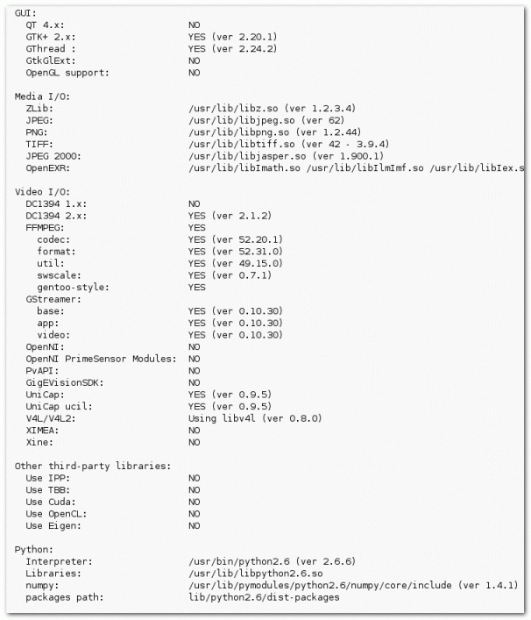

21) $ sudo make

**Now install OpenCV**

22) $ sudo make install

23) $ sudo ldconfig

Now configure system wide path

24) sudo nano /etc/ld.so.conf.d/opencv.conf

This will open up a file in which we need to add some address which is **‘/usr/local/lib’** as shown in figure. Here we are using ‘nano’ as editor instead of ‘gedit’

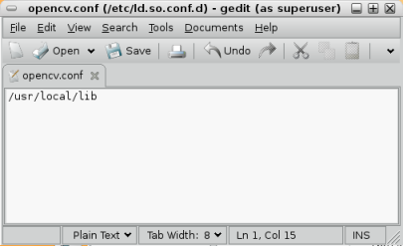

|  |
| --- |
|  |
|  |

Now we will**Setup the PKG_CONFIG_PATH variable. For this open** bash.bashrc file using command

25) sudo nano /etc/bash.bashrc

Inside this add two lines in the last of file. Please note down that here also we have used nano editor so screen appear during operation will be black which is different from the figure shown. But rest of work remains same.

PKG_CONFIG_PATH=$PKG_CONFIG_PATH:/usr/local/lib/pkgconfig

export PKG_CONFIG_PATH

